Review of The Small World Phenomenon

By Shitai Zhang

**Small-world phenomenon** was referred to the fact that social networks are so rich in short paths also known as “six degree of separation”.

**Stanley Milgram’s experiment:** ask random individual to forward a letter to a designated person live in Sharon, MA by providing the target’s name, address, occupation and some personal information.

Cannot mail the letter directly to the address;

Can advance the letter to an acquaintance on the first name basis with the goal of reaching the target as soon as possible.

**Results**: 1/3 of mail arrived at the target with median of 6 steps

**Implication**: the abundant existence of short paths in out social network; and these short paths can be found by collectively findings.

To model the existence and abundance of short paths in our social network:

***Pure Exponential Growth:*** we assume each people knows 100 people on a first-name basis, and by doing that, you can reach to 100 other people by first step, and each of your 100 acquaintance will bring another 100 people they know, continuously, you can reach out to a million people after third step and 10 billion people in 5th step, which means you can basically reach out to any people from Donald Trump to people live in China within 5 steps. This model implicitly assumes that each of 100 people you friend bringing in to your social network are mutually exclusively to your friends and your friends’ friends. But this assumption is somehow not aligning with our intuition, since friend’s friend tends to be your friend too. Due to this triangles, some of these edges are actually going from one of your friend to another of your friend instead of reaching the rest of world.

***The Watts-Strogatz model (figure 20.2-b) basic idea:***

Proposed a model that combined homophily (we connect with people who are like ourselves) with weak ties (the links to acquaintance that connect us to part of network that would otherwise be far away). Homophily is captured by having each node form a link to all other node within a radius of up to *r* grid steps away. Weak ties are captured by each node forms a link to k other nodes selected uniformly at random from the grid.

**Furthermore, they found a small fraction of randomness is enough to achieve the small world phenomenon- existence of short paths between each pair of nodes.**

To model the path can be collectively found:

Due to consideration of the feasibility, Milgram’s experiment allows people to forward the letter to only one person at a time. This process can fail to reach the target even if the short paths exist. And we want to know what properties are critical for success and how can we construct a random network.

**Decentralized Search Model:**

The WS model clearly fail to support such property. But mildly edit that each of k random edges is generated in a way that decays with distance.

Distance between two nodes: v and w is the number of grid steps between them, denoted d(v,w). In generating a random edges out of v, the we have edge link between v and w with probability proportional to d(v,w)^-q. And q determines the randomness of long range links, q cannot be either too small or too large. And actually the decentralized searching is most effective when q=2. The formal proof was on the last subsection of this chapter.

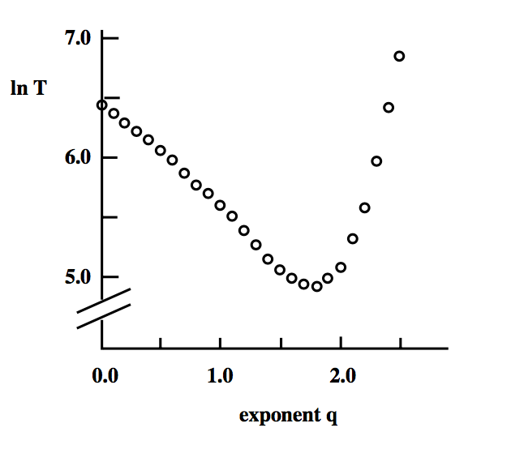

But this model actually assumes uniformly distribution and model on the physical distance. We make change some change on the model to fit the need of accommodate.

1. **Rank-based friendship** to accommodate the non-uniformly distribution. For a node v, he/she ranks all the rest nodes by proximity. Rank(w) is equal to the number of nodes closer to v than w. And the probability of forming a link between v and w is proportional to rank(w)^-p. And we found p=1 is the most efficient search. And the result on LiveJournal actually accommodate with this result.
2. Define social distance as the size of the smallest focus (any type of community that serves to organize social life around it) that contain both nodes. And the probability of forming an edge between v and w is proportional to dist(v,w)^-p. And we found when p equals 1, the resulting network supports efficient decentralized search with high probability.

Social status also plays an important role in the success of delivering letter to the designated target. Core-Periphery Structures: Social networks are structured to make high-status people much easier to find than low-status ones. Basically, high-status people are linked in a densely-connected core while low-status people are atomized around the periphery of the network.